2023 Midsem keynotes
1. Respiratory structures derived from the head and pharynx
2. Deepest fish found in which location
3. Taxonomic Characters which define measurements
4. Fish group with 7+ gill slits
5. Fish group with
6. Structure to detect vibration in water
10. Brain part corresponding to cerebrum
10. Sister group to Agatha
11. Cycloid scales found in which fish group
12. Which type of tail has equal lobes
13. Which type of movement involve undulations of the pectoral fins
13. Paired fins name
14. 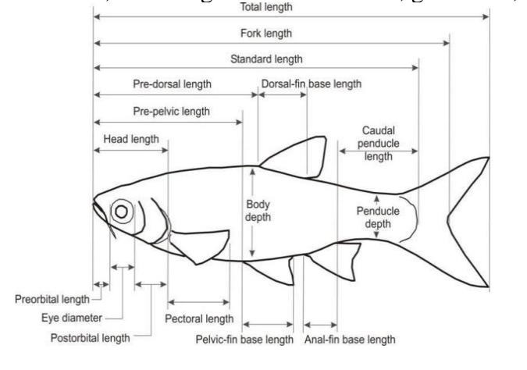
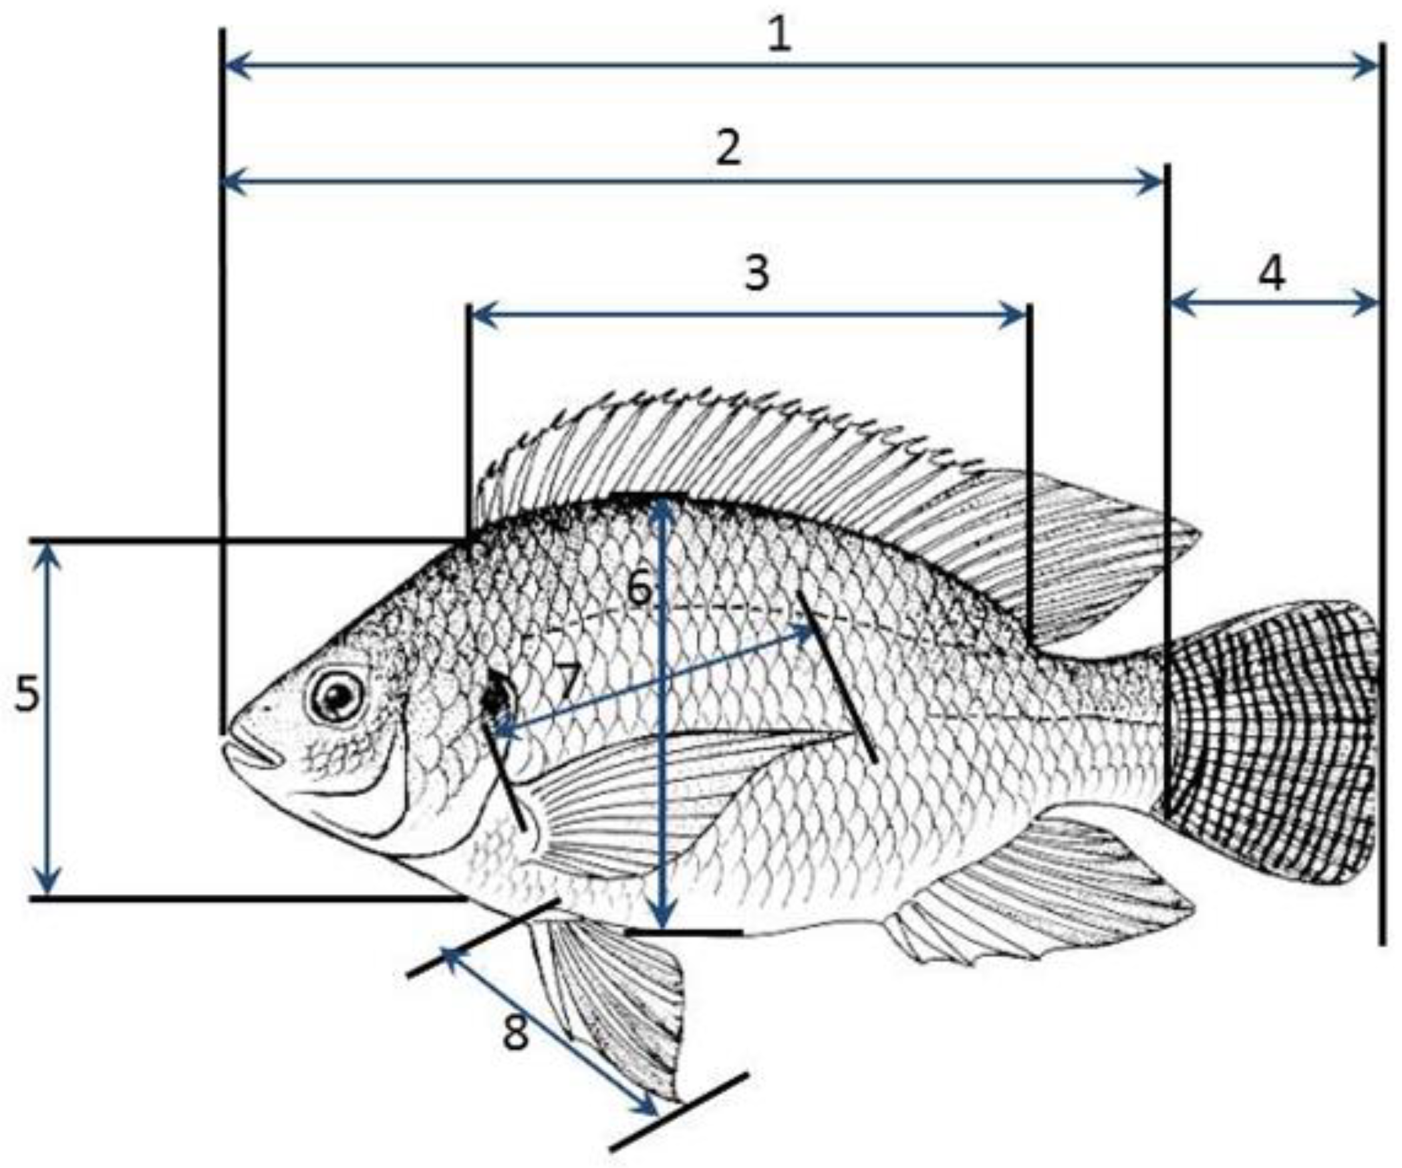
Know all the in the labels and what they represent.
15. Which of the labels represent paired fins
16. Scales derived from what
17. Which group of fish has pointed stiff straight fin rays
18. How different white muscles is from red muscles
19. Fish need to be hyperosmotic or hyposmotic to live in freshwater
18. Which structures are modifications of the gills
19. Which heart part has a lot of valves
20. Which group of feeding habits has a gut length of 3+
21. Most common reproduction type in fish
22. Which parts of fish used to determine the age
23. Which part of the brain is at the front
24. Fish exhibiting loud sounds amd moving about is what behaviour
25. How to calculate the standard metabolic rate thing. Table of values was given
26. Brood scarter,internal fertilization,external fertilization ,egg care ..arrange in order of increasing of parental care
27.What part of the fish brain if for homeostasis and hormone regulation
28.Which fish has cloaca ,clasper …
29. Fish that are able to move in a dense ,muddy area will have which kind of movement
30. Which fishes are extinct under the jaw fishes
31. Examples of accessory part of the respiratory thing
32. Which part of the organs has more valves. For the respiratory

Mcqs asscociated

1. Respiratory structures derived from the head and pharynx:
a) Gills
b) Lungs
c) Spiracles
d) Pseudobranch

2. Deepest fish found in which location:
a) Mariana Trench
b) Puerto Rico Trench
c) Java Trench
d) Sunda Trench

3. Taxonomic Characters which define measurements:
a) Body length
b) Fin length
c) Head width
d) Eye diameter

4. Fish group with 7+ gill slits:
a) Sharks
b) Bony fish
c) Lampreys
d) Rays

5. Fish group with a swim bladder:
a) Cartilaginous fish
b) Ray-finned fish
c) Lungfish
d) Lampreys

6. Structure to detect vibration in water:
a) Otoliths
b) Lateral line system
c) Ampullae of Lorenzini
d) Statocysts

7. Brain part corresponding to cerebrum:
a) Telencephalon
b) Diencephalon
c) Mesencephalon
d) Metencephalon

8. Sister group to Agnatha:
a) Chondrichthyes
b) Osteichthyes
c) Cyclostomata
d) Acanthodii

9. Cycloid scales found in which fish group:
a) Bony fish (Osteichthyes)
b) Cartilaginous fish (Chondrichthyes)
c) Lampreys (Agnatha)
d) Lungfish (Dipnoi)

10. Which type of tail has equal lobes:
a) Heterocercal tail
b) Diphycercal tail
c) Homocercal tail
d) Protocercal tail

11. Which type of movement involves undulations of the pectoral fins:
a) Hovering
b) Galloping
c) Walking
d) Flying

12. Paired fins name:
a) Pectoral and Pelvic fins
b) Dorsal and Anal fins
c) Caudal and Ventral fins
d) Opercular and Gular fins

13
1. In the diagram, which label corresponds to "Standard Length (SL)"?
a) Label 1
b) Label 2
c) Label 3
d) Label 4

2. What does Label 6 represent in the diagram?
a) Caudal fin length
b) Total length
c) Head length
d) Eye diameter

3. The length indicated by Label 5 in the diagram is:
a) Dorsal fin length
b) Pectoral fin length
c) Anal fin length
d) Pelvic fin length

4. Which label in the diagram represents the "Fork Length (FL)"?
a) Label 1
b) Label 2
c) Label 3
d) Label 4

5. The length indicated by Label 8 in the diagram is the:
a) Caudal peduncle length
b) Precaudal length
c) Total length
d) Snout length

6. What does Label 7 represent in the diagram?
a) Head length
b) Body depth
c) Caudal fin length
d) Eye diameter

7. The length represented by Label 3 in the diagram is:
a) Dorsal fin length
b) Caudal fin length
c) Precaudal length
d) Anal fin length

8. In the diagram, which label corresponds to "Total Length (TL)"?
a) Label 1
b) Label 2
c) Label 3
d) Label 4

9. The length indicated by Label 2 in the diagram is the:
a) Head length
b) Body depth
c) Pectoral fin length
d) Eye diameter

10. Which label in the diagram represents the "Caudal Peduncle Length"?
a) Label 1
b) Label 2
c) Label 3
d) Label 4

14. Which of the labels represent paired fins:
a) Pectoral and Pelvic fins

15. Scales derived from what:
a) Scales are derived from the epidermis.

16. Which group of fish has pointed stiff straight fin rays:
a) Acanthopterygii (Spiny-rayed fish)
b) Chondrichthyes (Cartilaginous fish)
c) Osteichthyes (Bony fish)
d) Agnatha (Jawless fish)

17. How different white muscles are from red muscles:
a) White muscles are used for burst movements and fatigue quickly.
b) White muscles are used for sustained activity and have more myoglobin.

18. Fish need to be hyperosmotic or hyposmotic to live in freshwater:
a) Hyperosmotic
b) Hyposmotic
c) Isosmotic
d) Hypertonic

19. Which structures are modifications of the gills:
a) Gill rakers and filaments
b) Lateral line system and gill arches
c) Swim bladder and gill cover
d) Pectoral and Pelvic fins

20. Which heart part has a lot of valves:
a) Atrium
b) Ventricle
c) Sinus venosus
d) Bulbus arteriosus

21. Which group of feeding habits has a gut length of 3+:
a) Carnivorous fish
b) Herbivorous fish
c) Omnivorous fish
d) Filter-feeding fish

22. Most common reproduction type in fish:
a) Oviparous reproduction (laying eggs)
b) Viviparous reproduction (live birth)
c) Ovoviviparous reproduction (eggs hatch inside the female)
d) Hermaphroditic reproduction

23. Which parts of fish are used to determine the age:
a) Scales
b) Otoliths (ear bones)
c) Fin rays
d) Gill cover

24. Which part of the brain is at the front:
a) Telencephalon (cerebrum)
b) Diencephalon
c) Mesencephalon
d) Metencephalon

25. Fish exhibiting loud sounds and moving about is what behavior:
a) Spawning behavior
b) Mating behavior
c) Predatory behavior
d) Aggressive behavior

26. How to calculate the standard metabolic rate:
a) Measure the oxygen consumption of the fish at rest.
b) Measure the carbon dioxide production of the fish during activity.
c) Measure the heart rate of the fish during exercise.
d) Measure the water intake of the fish in a controlled environment.

27. Arrange in order of increasing parental care:
a) External fertilization
b) Internal fertilization
c) Egg care
d) Brood care

28. What part of the fish brain is for homeostasis and hormone regulation:
a) Telencephalon
b) Diencephalon
c) Mesencephalon
d) Metencephalon

29. Which fish has cloaca and clasper:
a) Sharks
b) Bony fish
c) Lampreys
d) Lungfish

30. Fish that are able to move in a dense, muddy area will have which kind of movement:
a) Pectoral fin-based movement
b) Undulatory movement
c) Walking movement
d) Jet propulsion movement

31. Which fishes are extinct jawless fishes:
a) Ostracoderms
b) Placoderms
c) Acanthodians
d) Coelacanths

32. Examples of accessory parts of the respiratory system:
a) Barbels, spiracles, lungfish labyrinth organ
b) Operculum, scales, swim bladder
c) Pectoral and pelvic fins, gill rakers, gill filaments
d) Ampullae of Lorenzini, otoliths, lateral line system

33. Which part of the organs has more valves for the respiratory system:
a)

Gills
b) Lungs
c) Spiracles
d) Trachea

